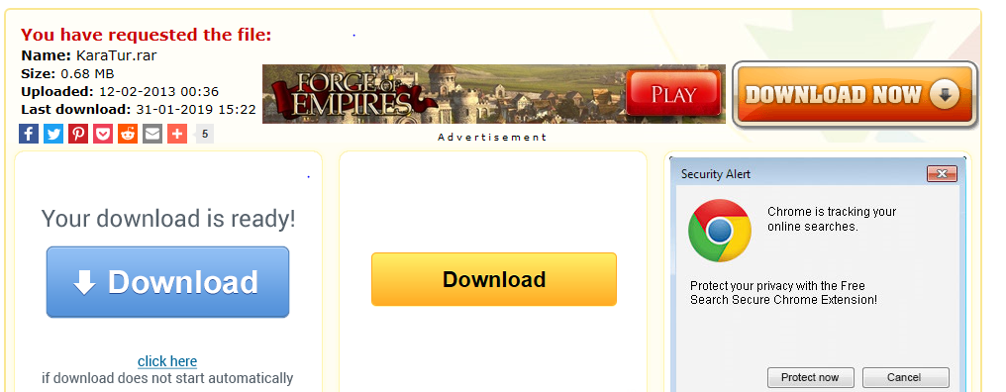

All three download buttons try to download malware. No mod.

